**Warm-up Lab Task: Print the following series using the while loop:**

* 1. Print numbers from 1 to 100 with increment of 1 (i.e. 1, 2, 3, … 100)
  2. Print numbers from 100 to 1 with decrement of 1 (i.e. 100, 99, 98, … 1)
  3. Print numbers from 20 to 2 in steps of -2
  4. Print sequence of numbers: 2, 5, 8, 11, 14, 17, 20
  5. Print sequence of numbers: 99, 88, 77, 66, 55, 44, 33, 22, 11, 0

**Lab Task 1:**

Write a program that inputs from user an integer and prints to the screen the table of that number up to 10 multiples. (**Hint**: First identify the loop counter variable and the steps to repeat in this problem)

**Sample Output**

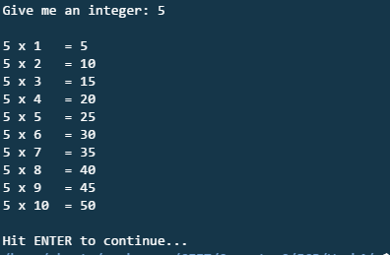

**Lab Task 2:**

Write a program which inputs N numbers form the user and displays the following at the end of the program:

* Number of positive, negative and zero-valued inputs (hint: you need to run 3 counters)
* Maximum number that was input
* Minimum number that was input

**Lab Task 3:**

[sentinel-controlled loop] Write a program which inputs numbers form the user until any negative number (e.g. -1) is entered. At the end, the program should display the following:

* Sum of even numbers
* Sum of odd numbers

**Hint:** In this program, all the negative values are sentinel values.

**Practice Task 1:**

**Program name:** Sum of even numbers within a range

**Program Purpose:** Usage of while loop along with if statement

**Problem Statement:** Write a C program that inputs 2 integers from the user and computes the sum of integers between these values. In this task, only even integers should be added to compute the sum. Finally, display the sum on screen.

**Sample Output:**

Enter first integer: 5

Enter second integer 14

The sum [6 + 8 + 10 + 12 + 14] is: 50

Hint: The pattern highlighted above is actually printed inside the loop. The plus symbol is shown each time a number is added to sum (except the last one in the sequence).

**Practice Task 2:**

